DEPATMENTAL PROFILE
1. NAME OF THE DEPARTMENT : COMPUTER SCIENCE
2. YEAR OF ESTABLISHMENT 2004
3. DEPARTMENTAL E-MAIL ID NA
4. PROGRAM OFFERED B. Sc. (CS), PGDCA
5. STAFF DETAILS: SANCTION POST 02
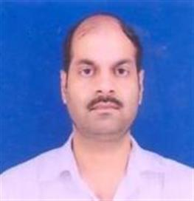
FILLED POST Nil
VACANT POST 02
- NAME Dr. MANOJ KUMAR RAO (HOD/Incharge)
- E-mail ID raomk.2008@rediffmail.com

6. TEACHING STAFF –Guest Faculty

- NAME MITHILESH PATEL
- E-mail ID mr.mithilesh.patel@gmail.com
- Qualification M.Tech. , NET,SET

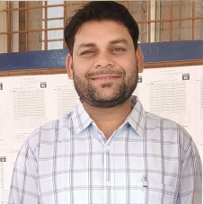
- NAME Dr. SATISH KUMAR TEWALKER
- E-mail ID satishtewalker2@gmail.com
- Qualification Ph.D., M.Phil. , M.C .A.

7. LAB TECHNICIAN No
8. LAB BEARER No
9. STUDENT STRENTH
UG (B.Sc.) | PG (PGDCA) | RESEARCH
40 | 40 | 0

10. SWOC ANALYSIS
- Strengths

- Weaknesses

- Opportunities

- Challenges

